**Offroad Challenge Tracker**

* **Design:**

**(i) Entity-Relationship Diagram:**

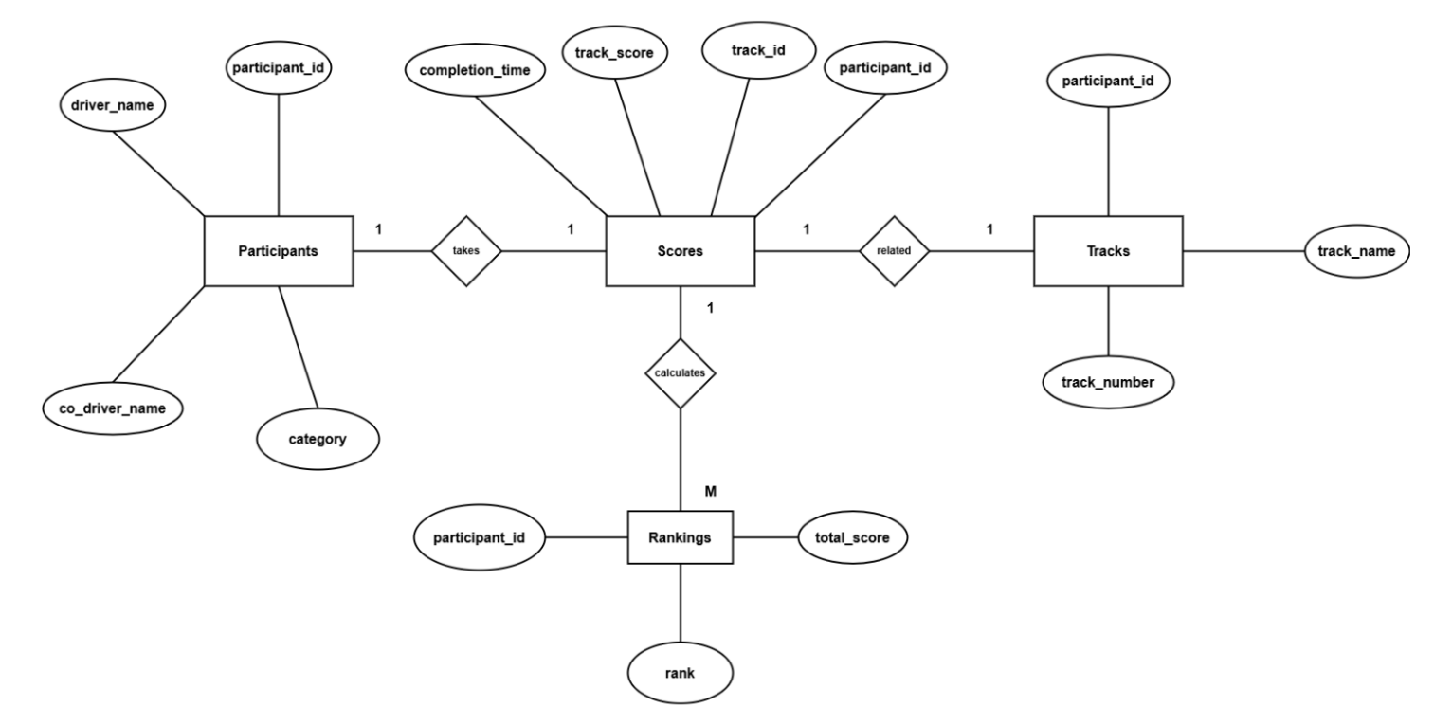

**(ii) Use-Case Diagram:**

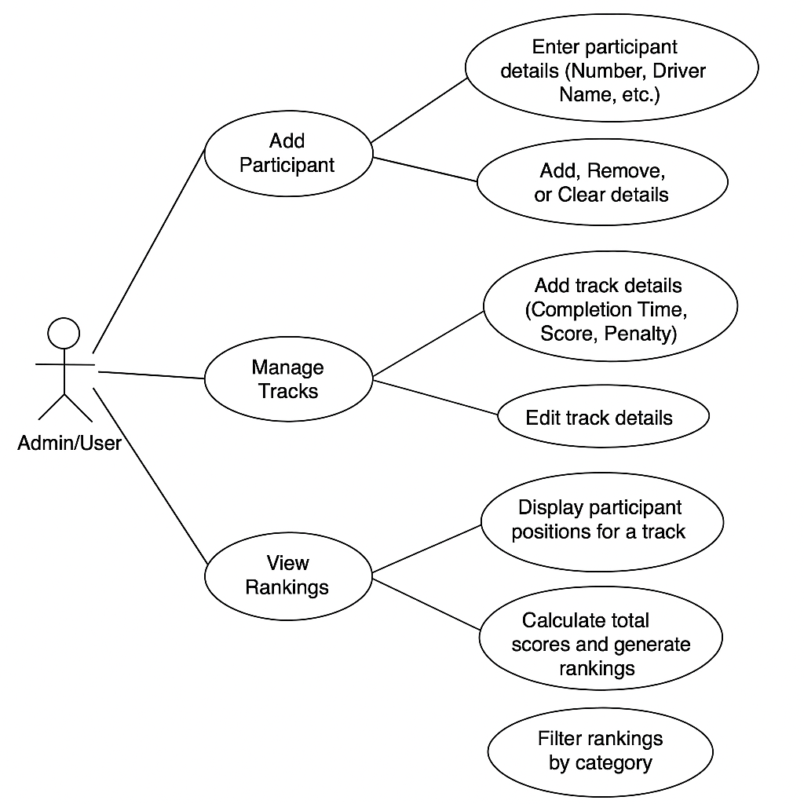

**(iii) Class Diagram:**

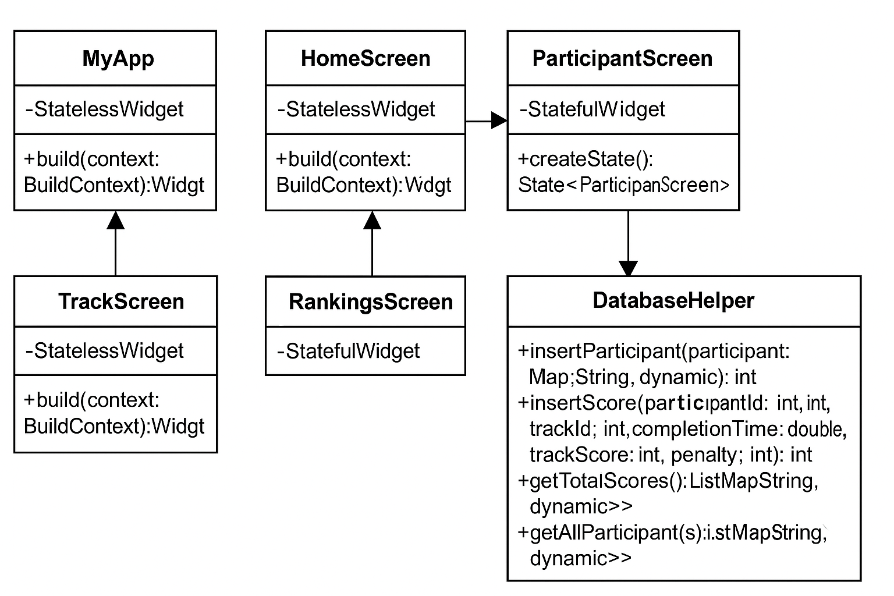

* **Implementation:**

**(i) Database Design:**

**Overview**

**The Offroad Tracker Database is designed to manage participants, tracks, scores, and rankings for an off-road event tracking system. The database consists of four primary tables: Participants, Tracks, Scores, and Rankings. These tables store information about competitors, race tracks, performance scores, and overall rankings.**

**Database Schema**

**1. Participants Table**

**Stores information about event participants.**

|  |  |  |
| --- | --- | --- |
| **Column Name** | **Data Type** | **Constraints** |
| **id** | **INTEGER** | **PRIMARY KEY, AUTOINCREMENT** |
| **participant_number** | **INTEGER** | **UNIQUE, NOT NULL** |
| **driver_name** | **TEXT** | **NOT NULL** |
| **co_driver_name** | **TEXT** | **NOT NULL** |
| **category** | **TEXT** | **NOT NULL** |

**2. Tracks Table**

**Stores information about different tracks in the event.**

|  |  |  |
| --- | --- | --- |
| **Column Name** | **Data Type** | **Constraints** |
| **id** | **INTEGER** | **PRIMARY KEY, AUTOINCREMENT** |
| **track_name** | **TEXT** | **NOT NULL** |
| **track_number** | **INTEGER** | **UNIQUE, NOT NULL** |

**3. Scores Table**

**Stores performance details for each participant on specific tracks.**

|  |  |  |
| --- | --- | --- |
| **Column Name** | **Data Type** | **Constraints** |
| **id** | **INTEGER** | **PRIMARY KEY, AUTOINCREMENT** |
| **participant_id** | **INTEGER** | **NOT NULL, FOREIGN KEY REFERENCES Participants(id) ON DELETE CASCADE** |
| **track_id** | **INTEGER** | **NOT NULL, FOREIGN KEY REFERENCES Tracks(id) ON DELETE CASCADE** |
| **completion_time** | **REAL** | **NOT NULL** |
| **track_score** | **INTEGER** | **NOT NULL** |
| **penalty** | **INTEGER** | **DEFAULT 0** |

**4. Rankings Table**

**Stores the calculated rankings of participants based on their performance.**

|  |  |  |
| --- | --- | --- |
| **Column Name** | **Data Type** | **Constraints** |
| **id** | **INTEGER** | **PRIMARY KEY, AUTOINCREMENT** |
| **participant_id** | **INTEGER** | **NOT NULL, FOREIGN KEY REFERENCES Participants(id) ON DELETE CASCADE** |
| **total_score** | **INTEGER** | **NOT NULL** |
| **rank** | **INTEGER** | **NOT NULL** |

**Business Rules & Logic**

**1. Participants must be unique based on participant_number.**

**2. Tracks must have unique numbers (track_number).**

**3. Scores are calculated using the formula:**

total_score = SUM(track_score - penalty - completion_time)

**4. Rankings are assigned dynamically** using SQL RANK() function based on total_score.

**5. Foreign Key Constraints ensure data integrity**:

1. If a participant is deleted, their scores and rankings will also be deleted (ON DELETE CASCADE).

2. If a track is deleted, all related scores are removed.

**Queries & Operations**

**Inserting a New Participant**

Future<int> insertParticipant(Map<String, dynamic> participant) async {

final db = await instance.database;

return await db.insert('Participants', participant);

}

**Recording a Score**

Future<int> insertScore(int participantId, int trackId, double completionTime, int trackScore, int penalty) async {

final db = await instance.database;

return await db.insert('Scores', {

'participant_id': participantId,

'track_id': trackId,

'completion_time': completionTime,

'track_score': trackScore,

'penalty': penalty,

});

}

**Retrieving Total Scores**

SELECT participant_id, SUM(track_score - penalty - completion_time) AS total_score

FROM Scores

GROUP BY participant_id

ORDER BY total_score DESC;

**Retrieving Rankings**

SELECT participant_id,

RANK() OVER (ORDER BY SUM(track_score - penalty - completion_time) DESC) AS rank

FROM Scores

GROUP BY participant_id;

**(ii) User-Interface Design:**

**Overview**

**The Offroad Challenge Tracker application provides an intuitive and user-friendly interface for managing participants, tracking scores, and viewing rankings in an off-road event. The UI follows a clean and structured layout with navigation between screens using Flutter's Material Design principles.**

**Screens and Navigation**

**1. Home Screen**

**File:** home_screen.dart

* **Purpose: Serves as the main hub for navigation.**
* **Components:**
  + **Title: "Offroad Challenge Tracker"**
  + **Buttons:**
    - **"Manage Participants" → Navigates to the ParticipantScreen**
    - **"View Rankings" → Navigates to the RankingsScreen**

**2. Participant Management Screen**

**File:** participant_screen.dart

* **Purpose: Allows users to add, view, and delete participants.**
* **Components:**
  + **Floating Action Button (FAB): Opens a dialog to add a new participant.**
  + **List of Participants: Displayed using ListView.builder.**
  + **Participant Card: Shows driver name, co-driver name, and category.**
  + **Dismissible Cards: Swipe to delete a participant.**
* **Dialog Components:**
  + **Text Fields: Input for driver_name and co_driver_name.**
  + **Dropdown Menu: Select category (Stock, Mod Petrol, Mod Diesel, Pro, Ladies + Pro).**
  + **Buttons:**
    - **"Add Another" → Adds another participant without closing the dialog.**
    - **"Submit" → Navigates to TrackScreen.**

**3. Rankings Screen**

**File:** rankings_screen.dart

* **Purpose: Displays the rankings of participants.**
* **Components:**
  + **AppBar Title: "Rankings"**
  + **List of Participants and Ranks: Retrieved from the database.**
  + **Fallback Message: Displays "No rankings available" if no data is found.**

**4. Track Management Screen**

**File:** track_screen.dart

* **Purpose: Placeholder screen for managing tracks.**
* **Components:**
  + **Title: "Add Tracks"**
  + **Centered Text: "Track Management Screen"**

**5. Participant Card Widget**

**File:** participant_card.dart

* **Purpose: Reusable widget for displaying participant information.**
* **Components:**
  + **Circle Avatar: Icon representation of the participant.**
  + **Text Details: Driver and co-driver names along with category.**
  + **Delete Button: Allows participant deletion.**
* **Features:**
  + **Uses Dismissible for swipe-to-delete functionality.**
  + **Animated UI effects for smooth transitions.**

**Theming and Design Elements**

* **Typography: Uses GoogleFonts.poppins for a modern look.**
* **Primary Colors:**
  + **primarySwatch: Colors.blue**
  + **backgroundColor: Colors.grey[100]**
* **Button Styles:**
  + **Elevated Buttons: Standardized padding and text size for consistency.**
  + **FAB: Styled with blueAccent and an add icon.**
* **Dialog Styling:**
  + **Rounded corners for a softer UI appearance.**
  + **Intuitive layout for input fields and actions.**
* **List Styling:**
  + **Shadows and rounded corners for a modern card-style layout.**
  + **Swipe-to-delete functionality for user-friendly interactions.**

**Navigation Flow**

1. **Home Screen → Tap "Manage Participants" → Opens ParticipantScreen.**
2. **ParticipantScreen → FAB to add participant → Dialog opens for input.**
3. **After Adding Participants:**
   * **Tap "Submit" → Navigates to TrackScreen.**
   * **Rankings update automatically when scores are entered.**
4. **Home Screen → Tap "View Rankings" → Opens RankingsScreen.**